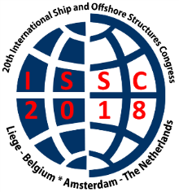

**20th International Ship and Offshore Structures Congress, 9 – 13 September 2018, Belgium & The Netherlands**

**GENERAL INFORMATION please read this carefully before leaving your country.**

**Dear participant**,

Still a few weeks to go and you will participate in our ISSC2018 conference. You are most welcome. In this General information we want to give you all necessary information to make your conference a fruitful, pleasant and relaxed one. The programme of the conference will be handed over to you during registration.

**Warm welcome to your partners too!** We have a small programme organized specially for them. Please have a look at the bottom of this information.

**TRAVEL INFORMATION**

**Arrival at Schiphol Airport, Amsterdam: go to Liege by train**

**IMPORTANT**: **please buy your train tickets ON LINE and have them printed before you leave your home country.** The Netherlands has several providers for train tickets and you might have to wait a long time at the desk at the station. Please consider the time to leave the plane, get your luggage and walk to the trains. Several trains leave for Liege Guillemins. This station is located close to our Palais des Congres and the hotels. Travel time from Schiphol Airport to Liege is about 3.30 hrs, by Thalys about 2.30 hrs. A taxi from the station to your hotel is rather cheap in Liege, € 1,65 per kilometre. Follow the signs: **To the trains** on Schiphol Airport.

From Brussels: Many trains go from Brussels-South to Liege-Guillemins as well. Travel time about 1 hour. You can book your train ticket ON-LINE (and print them out please!) through this link:

Book all your train tickets to this station: Liege Guillemins.

<https://www.nsinternational.nl/en/traintickets#/>

**Hotels:** You have booked your hotel in Liege yourself. Many of you stay in Van der Valk, the hotel next to the Palais des Congres. If you did not book Van der Valk Hotel please **INFORM US ON YOUR HOTEL in Liege by email** [**info@issc2018.org**](mailto:info@issc2018.org)**.** On Monday night we have the informal Conference dinner in Chateau Colonster. We can have a bus drive along your hotel: if we know where you are…..and the next morning the bus can pick you up to bring you and your luggage to the boat.

**PLEASE INFORM US BY EMAIL:** [**info@issc2018.com**](mailto:info@issc2018.com)

**TECHNICAL INFORMATION FOR LECTURERS**

**Lecturers: Mirek Kaminski has asked you by email to send your presentation to us before the congress. We would like to put all your presentations on a stick. Please send it to us, by email and before 3 September. Thank you!**

**Laptops will be available in the lecture hall. If you insist to use your own laptop it is ok to us. Technicians and student assistants will help you with your computer.**

**PROGRAMME & EVENTS**

**Sunday 9 September: Registration & Reception at the University**

[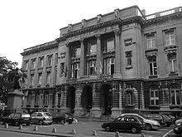](https://www.google.nl/url?sa=i&rct=j&q=&esrc=s&source=images&cd=&ved=2ahUKEwjB0-Ha84DdAhUCYVAKHVW8Ba8QjRx6BAgBEAU&url=https://fr.wikipedia.org/wiki/Universit%C3%A9_de_Li%C3%A8ge&psig=AOvVaw0aAcHT40PlSF-_qdNwIWXt&ust=1535035691222731)

**Address: Place du 20 Août 7, 4000 Liège**

Registration opens at 16.00 hrs. During the registration we organize a reception with drinks & snacks, so you can register at ease! When you come in and see a busy line before the registration desk, have a drink first. Welcome speech in The Academic Room at 17.45 hrs. This reception ends at 20.00 hrs. During the registration a detailed programme of the lectures & events will be handed over to you. Please arrange your own transport to this reception, by foot or by taxi.

In Liege nice restaurants & shops are located at the Place du Marchee, Taxis are not expensive, please look at the signs inside the taxi: 1,65 Euro per kilometre before 22.00 hrs., late night kilometres are more expensive.

**Payments & Reimbursements:** some of you have to pay some items to us, some of you have a reimbursement. For CASH payments, please do so during the quiet moments on Monday in Palais des Congres , Liege. We have your invoices ready for you. Please, for the reimbursements, come to the registration desk in Hotel Zuiderduin and bring the invoices you paid for.

**IF YOU DID NOT PAY YET, PLEASE PAY CASH AT THE CONFERENCE DESK**

**Monday 10 September: Palais des Congres**

[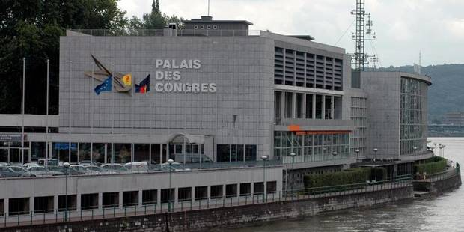](https://www.google.nl/url?sa=i&rct=j&q=&esrc=s&source=images&cd=&cad=rja&uact=8&ved=2ahUKEwjj-ZDW9IDdAhXGL1AKHRmIDEoQjRx6BAgBEAU&url=https://www.sspf.be/fr/liege-palais-des-congres-formation-en-journee-pharmaciens.html?IDC%3D156%26IDD%3D67108899&psig=AOvVaw239uuSM1aEDmPEJYTm2fnm&ust=1535035946299478)

**Address: 2, Espl. de l'Europe, 4020 Liège**

The conference officially opens at 9.00 hrs. If you have not attended the Sunday reception you can register between 8.00 – 9.00 hrs at the registration desk in the foyer. This day is fully filled by lectures.

The programme ends at approx. 17.00 hrs. At 17.10 hrs buses will drive you to the hotels in the centre of Liege. You can have a quick change of clothes (if you prefer of course!) and will be picked up at 18.00 hrs by bus. This night we have an informal dinner at Chateau Colonster, please enjoy this dinner informally dressed.

Before we go to Chateau Colonster, Professor Philippe Rigo proudly presents his Laboratory to you. The buses will stop at his lab for approx. 45 minutes.

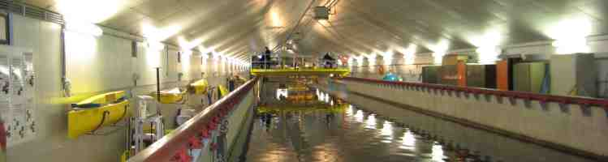

**Address: Allee de Decouverte 9, Liege**

**WELCOME TO ANAST - FACULTY OF ENGINEERING**

**6:30- 7:30pm SHORT TECHNICAL VISIT**

**MORE INFORMATION FOR THIS VISIT PLEASE LOOK AT THE BOTTOM OF THIS DOCUMENT**

**Conference dinner at Chateau Colonster**

After the lab visit we continue our trip to Chateau Colonster:

[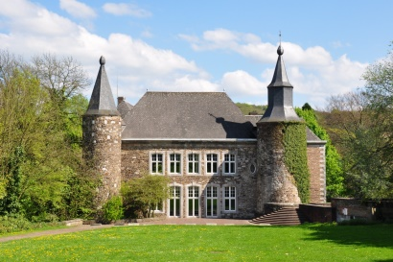](http://www.google.nl/url?sa=i&rct=j&q=&esrc=s&source=images&cd=&cad=rja&uact=8&ved=2ahUKEwiJ0Ivt9IDdAhUKKFAKHXIVAyQQjRx6BAgBEAU&url=http://mapio.net/pic/p-18359719/&psig=AOvVaw3sSrw7PI6N619PSQEee_E7&ust=1535035997522240)

**Address: Allee des Erables, 4000 Liège**

We will arrive at the Chateau between 19.30 – 19.45 hrs. After a welcome drink , our Walking dinner starts at 20.00 hrs. An informal gathering! At 22.00 hrs the first bus will start driving back to the hotels. The last bus will leave at 22.30 hrs. You will all be in your hotel at a reasonable time. Please consider an early rise next morning as we leave Liege by boat at 08.00 hrs!

**Tuesday 11 September**

Early rise, have breakfast and take the bus at your hotel or take a taxi to Palais the Congres. One more time: **PLEASE LET US KNOW IN WHICH HOTEL YOU ARE!!!!**

[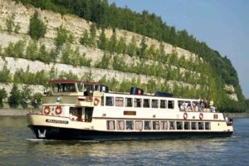](https://www.google.nl/url?sa=i&rct=j&q=&esrc=s&source=images&cd=&cad=rja&uact=8&ved=2ahUKEwjfh-KL9YDdAhWQaFAKHW8EB8kQjRx6BAgBEAU&url=https://congressteden.nl/rederij-stiphout-maastricht/&psig=AOvVaw3lbwqeMUXQCwka-hhOKxjh&ust=1535036058364173) [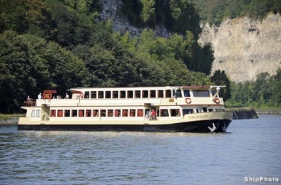](https://www.google.nl/url?sa=i&rct=j&q=&esrc=s&source=images&cd=&cad=rja&uact=8&ved=2ahUKEwjDhLSh9YDdAhVNbFAKHbkmAbEQjRx6BAgBEAU&url=https://www.binnenvaart.eu/passagiersschip/32876-scheldevallei.html&psig=AOvVaw1GJKKTya5DNezcefFHzg-G&ust=1535036108014824)

The boats: De Scheldevallei Boat Nr 1 and De Geulvallei Boat nr 2 lie in front of the Palais des Congres/Van der Valk Hotel. You can put your luggage in the bus (please remember the number of the bus you put your luggage in!)

You go to Boat no 1 or 2 (you have chosen a boat while you registered on our website). Lectures will be given on the boat, you will enjoy coffee during the break. After the lectures there is lunch on board. Around 14.00 hrs our buses will be at the Kanaalweg, just before the Genk’s Lock in the Albert Canal. Please, again, note the number of the bus you put your luggage in.

Back in the bus we drive to Antwerp, to visit the Flanders Hydraulics Laboratory.

[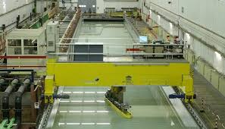](https://www.google.nl/imgres?imgurl=http://www.shallowwater.ugent.be/img/ttfig1.jpg&imgrefurl=http://www.shallowwater.ugent.be/EN/kc_fac_st_EN.htm&docid=f1LiO_MhokfNDM&tbnid=_JVHNmGdkc9K8M:&vet=10ahUKEwinj9XE9YDdAhWQfFAKHerLAWIQMwhdKBYwFg..i&w=593&h=340&hl=nl&bih=1024&biw=1920&q=flanders%20hydraulics%20research%20belgium&ved=0ahUKEwinj9XE9YDdAhWQfFAKHerLAWIQMwhdKBYwFg&iact=mrc&uact=8)

**Address: Berchemlei 115, 2140 Antwerp, Belgium**

We arrive there around 15.00 hrs. In the lab you follow your group (the number of the bus is the number of your group during the guided tours in the lab). You will visit: towing tank, a model of Zeebruge harbour, ship simulator and more.

The tour ends at approx. 17.30 hrs, a reception with drinks & snacks will follow.

Between 18.30 – 19.00 hrs the buses pick us up and we leave for The Netherlands. Please again: get on YOUR bus where your luggage has been stowed. We expect a 2,5 hour drive to our Hotel Zuiderduin in Egmond aan Zee.

[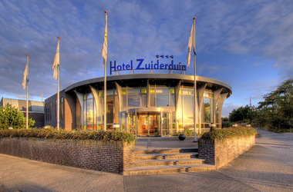](http://www.zuiderduin.nl/htmlpagina.asp?lnk=welkom.htm&page=1)

**Address: Zeeweg 52, 1931 VL Egmond aan Zee**

**Some of you did not make a reservation in Hoel Zuiderduin, we still have some rooms, please inform us as soon as possible if you want to have a room for the in-house conference!**

The hotel will help you as soon as possible with your key for the room. Meanwhile warm snacks and drinks are waiting for us in The Foyer. You can eat it in The Foyer, you can also take it to your room. A floor programme of the hotel will be printed in our programme.

The end of an interesting day!

**Wednesday 12 September**

Lectures all day in plenary session. Coffee breaks take place in The Foyer. Lunch is served in the restaurant (buffet cold & hot meals). The beach is within a walking distance of 3 minutes.

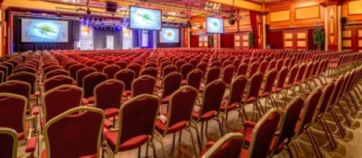

No dinner served tonight. You can choose one of the nice and cosy restaurants near the sea in Egmond or have dinner in the hotel (on your own expenses) . They are within the same 3 minutes walking distance.

You are kindly invited to our free Bowling from 22.00 – 24.00 hrs. Drinks and snacks are complementary to our participants.

**Thursday 13 September**

In the morning we have 2 parallel sessions. After lunch we gather in a plenary session where the Chairman of the Standing Committee will explain the coming 2 hours. All new committees gather and choose their Chairman. This process will take a few hours.

Thursday night we have our formal Conference dinner in Hotel Zuiderduin. After having enjoyed an aperitif we sit down for dinner at reserved tables, mentioned by the Committee’s number and name. During dinner the next location of the ISSC2021 conference will be announced. During dinner we have some musicians playing nice and cosy music.

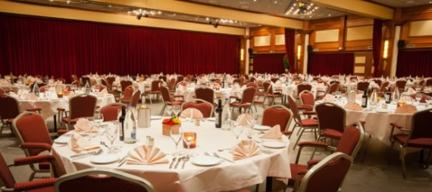

And...we have an After-Party from 22.00- 24.00 hrs with the Froude Music band, a band of Maritime students of TU Delft! Drinks & snacks are served.

End of the official part.

**Friday 14 September**

You have all chosen to go your own way today. Some of you go home. Some of you stay in Egmond aan Zee to gather in the ISSC-ITTC meeting with Professor Soares. Please note that you have to change hotels for the night of 14/15 September. You are located in Hotel Golfzang, this hotel is also owned by Hotel Zuiderduin. They will give you all information.

**REQUEST TO THE ISSC-ITTC MEETING; PLEASE CONFIRM YOUR STAY FOR THE NIGHT OF 14/15 SEPTEMBER TO US by email:** [**info@issc2018.org**](mailto:info@issc2018.org)

Some of you go to Delft for the Hexapod meeting and of course some touristic events like The Blue Pottery factory in Delft.

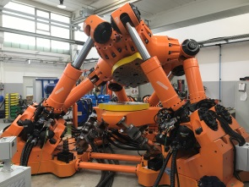 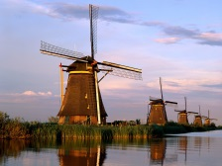 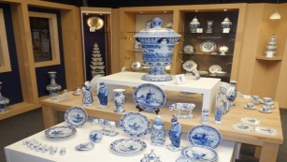

**BUS TRANSPORT to Schiphol Airport, Amsterdam Centre and Delft University of Technology**

During our stay in Hotel Zuiderduin, please note the Flipovers next to the registration desk: here we will announce the bus transport schedule. You can fill out your name for the bus of your choice.

**Programme Accompanying persons:**

You are welcome to all our events (dinners) and lunches and of course you come along on the boat and on the bus to The Netherlands! At this moment we have 17 accompanying persons, a cosy little group.

**Monday 10 September**: departure at 9.30 hrs from Hotel Van der Valk for an excursion to Durbuy, a cosy little town in the Ardennes Region (1 hour drive) . You will be back in your hotel at about 16.00 hours. Your host during the day will be Mrs. Pauline de Ruijt.

**Tuesday 11 September:** travelling to The Netherlands by boat & bus.

**Wednesday 12** **September:** no programme, you can choose for shopping in Egmond aan Zee, go to Amsterdam by taxi or have a day at the beach (weather….).

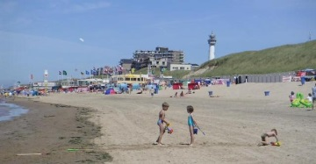

**Thursday 13 September**: Departure 9.30 hrs from Hotel Zuiderduin to Amsterdam (by bus). Return at approx. 16.00 hrs in our hotel. Pauline de Ruijt will again guide you today. A boat tour through our famous Amsterdam canals and a visit to one of our museums (Van Gogh or Rijksmuseum).

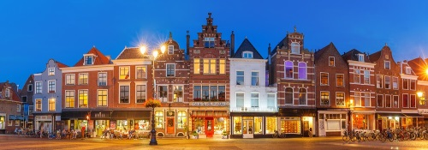

Formal conference dinner in Hotel Zuiderduin during the night.

**Some facts & handy tips :**

**TRAVEL INFORMATION**

**Arrival at Schiphol Airport, Amsterdam: go to Liege by train**

**IMPORTANT**: **please buy your train tickets ON LINE and have them printed before you leave your home country.** The Netherlands has several providers for train tickets and you might have to wait a long time at the desk at the station. Please consider the time to leave the plain, get your luggage and walk to the trains. Several trains leave for Liege Guillemins. This station is located close to our Palais des Congres and the hotels. Travel time from Schiphol Airport to Liege is about 3.30 hrs, by Thalys about 2.30 hrs. A taxi from the station to your hotel is rather cheap in Liege, € 1,65 per kilometre. Follow the signs: **To the trains** on Schiphol Airport

From Brussels: Many trains go to Liege-Guillemins as well. Travel time about 1.50 hrs. You can book your train ticket ON-LINE (and print them out please!) through this link:

Book all your train tickets to this station: Liege Guillemins

<https://www.nsinternational.nl/en/traintickets#/>

**Weather:**

In Liege the weather still be nice and warm in September, The 14 days forecast predicts a temperature between 23-25 degrees Celsius, no rain expected. It sounds positive!

In Egmond aan Zee we live somewhat closer to the sea. In September average temp is around 20 degrees Celsius. Predictions are like these temperatures.

**Money:** Currency in Belgium, as well as in The Netherlands is the **EURO**. Money devices are everywhere in Liege and Egmond aan Zee. In most shops you can pay with your credit card.

**Hotel Zuiderduin/Egmond aan Zee:**

The conference will take place at Hotel Zuiderduin in Egmond aan Zee, The Netherlands. The hotel is located almost at the beach of the picturesque seaside village of Egmond aan Zee, at 45 km from Amsterdam. The borough of Egmond consists of a trio of villages. Egmond-Binnen is the farthest inland, surrounded in spring by colorful fields of bulbs in bloom. The historical Adelbertusfield was already cultivated in the ninth century by monks from ancient Egmond Abbey. The Abbey was laid waste in the sixteenth century and rebuilt several times since. Today Benedictines live there. They welcome visitors interested in their candlemaking activities. In Egmond aan den Hoef one finds the Historical Information Centre. Many sights here remind the visitor of times past, in which the famous counts of Egmond played a prominent role. Only remnants of the castle are left, but the chapel is still intact and can be visited. Egmond aan Zee started as a medieval fishing village. The scene is dominated by the "Jan van Speijk" lighthouse, named after a naval hero. The modern station of the Royal Dutch Rescue Service has replaced the shed that housed the rowing boat in which volunteers risked their lives to get sailors off ships in distress among the dangerous shoals along the coast. The wide sandy beach invites swimmers, surfers and sunbathers, and features pavilions and other facilities. Alfresco pubs and restaurants, a subtropical swimming paradise, sports facilities and a lively shopping district make for a perfect holiday atmosphere. Where the village ends, the natural beauty of the Noord-Holland Dune Reserve begins.

**Hosts during the conference**

**Registration desk :** The registration desk will be open during conference hours.

During the conference you can ask all your questions to:

Mrs. Monique Gazendam, Mrs. Anouk de Goede, Mrs Pauline de Ruijt , Mrs. Dineke Heersma.

**Our technical crew**: our Maritime students: Hugo Verhelst, Stefan van der Harst , Fernando Tejero and Martin van der Eijk.

For all questions before the conference please use: [info@issc2018.com](mailto:info@issc2018.com)

We are looking forward to meeting you all in Belgium & The Netherlands. Have a safe trip.

Professor dr ir Mirek Kaminski, Chairman, Professor Philippe Rigo, Co-Chairman and Dineke Heersma, Organizing Committee

**______________________________________________________________**

**EXTRA INFO FOR MONDAY 10 SEPTEMBER, VISIT LABORATORY/DINNER**

|  |  |
| --- | --- |
|  |  |

**WELCOME TO THE UNIVERSITY OF LIEGE AND THE COLONSTER CASTLE**

**6:30- 7:30pm SHORT TECHNICAL VISIT ANAST**

**8:00 – 10:00/10:30 pm WELCOME DINNER at ULiege COLONSTER CASTLE**

Departure by coaches at 6:00 PM (sharp) from the PALAIS DES CONGRES & RAMADA and IBIS HOTELS

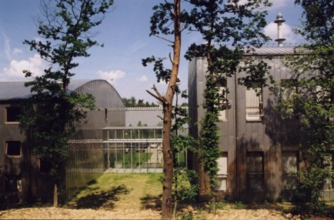The VISIT – **FACULTY OF ENGINEERING - ANAST**

You will have the opportunity to visit 3 Labs (wind tunnel, Towing tanks and structural labs) and take first refreshment

Address  

**UNIVERSITY of LIEGE – SART TILMAN Campus - ANAST**

Quartier POLYTECH 1 , Allé de la Découverte 9, Bat. B52/3 , 4000 LIEGE 1 , BELGIUM

<https://www.campus.uliege.be/cms/c_1841746/en/b52/3-mecanique-genie-civil-bureaux>

Longitude: 5° 33' 28.911" (5.558030605316162) - Latitude: 50° 35' 6.2232" (50.585062287858925)

Transfer by coaches : 7:15- 7:30   pm (5- minutes)

THE DINNER (at 7:30-7:45 pm)

At **ULiege COLONSTER CASTLE,** Château de Colonster, Allêe des Erables, 4000 Liège

Photos : <https://www.campus.uliege.be/cms/c_9306139/en/in-pictures-chateau-de-colonster>

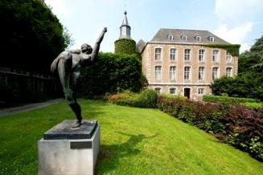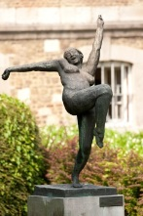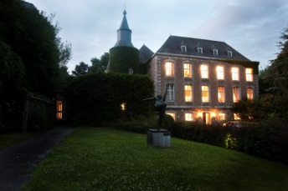

Access: <http://www.colonster.ulg.ac.be/english/acces.html>

|  |  |
| --- | --- |
|  |  |
|  |  |

**WELCOME TO ANAST - FACULTY OF ENGINEERING**

**6:30- 7:30pm SHORT TECHNICAL VISIT**

**Departure by coaches at 7:15- 7:30  pm (5 minutes) to COLONSTER CASTLE**

The VISIT –**- ANAST**

You will have about 45 minutes to visit one (maybe 2) labs of the Faculty of Engineering.

They are close each other and you will be able to walk and enter in these facilities.

In principle only 20-30 persons can enter at the same time.

Be patient and respect the security measure.

In front on the B52 building, you will find some refreshment.

Feel free to taste the typical JUPILER local beer.

Enjoy and do not hesitate to ask questions.

Regards

Ph RIGO A. HAGE G DIMITRIADIS J-P JASPART

Professor Professor Professor Professor

Co-Chair ISSC Towing Tank Wind Tunn el Structural Lab.



**MARIN DN&T SECO**

**Flanders Hydraulics Research**